Steps:

* Step 1: Make each data point single-point cluster that forms N clusters
* Step 2: Take the two closest data points and make them one cluster that forms N-1 clusters
* Step 3: Take the two closest clusters and make them one cluster that forms N – 2 clusters
* Step 4: Repeat Step 3 until there is only one cluster
* Repeat step 3 and for until
* Fin

Euclidean distance:

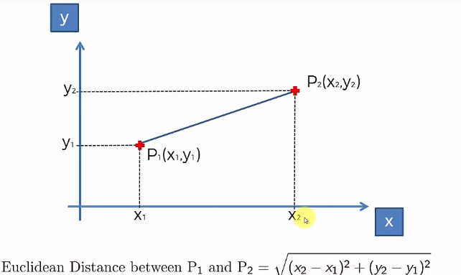

Distance between clusters:

1. Closest points
2. Furthest points
3. Average distance
4. Between centroids

How Do Dendrograms Work ?

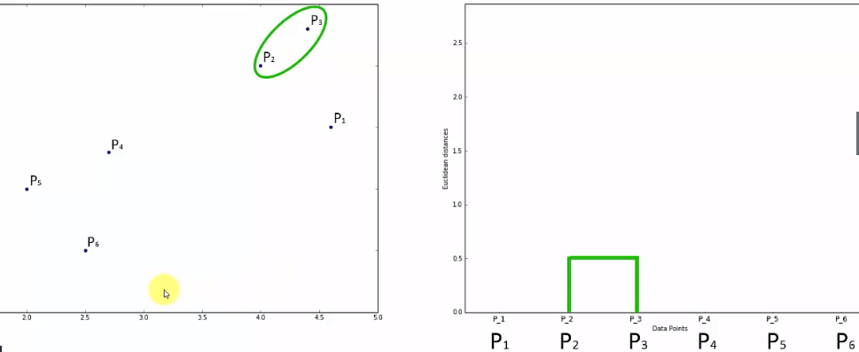

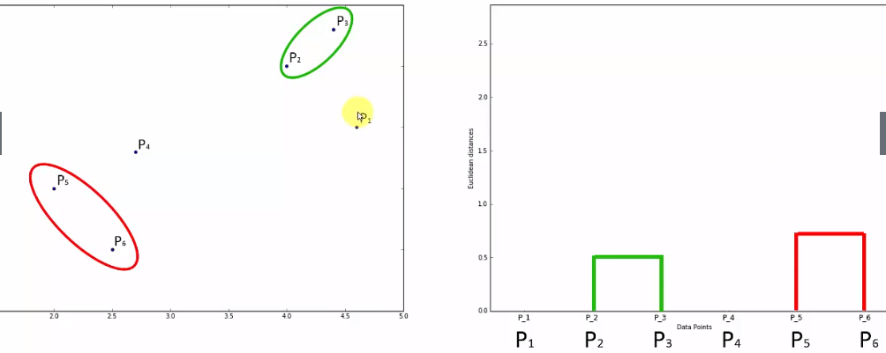

Since p3 close to p1 and p2 we join p3 with them in a cluster.

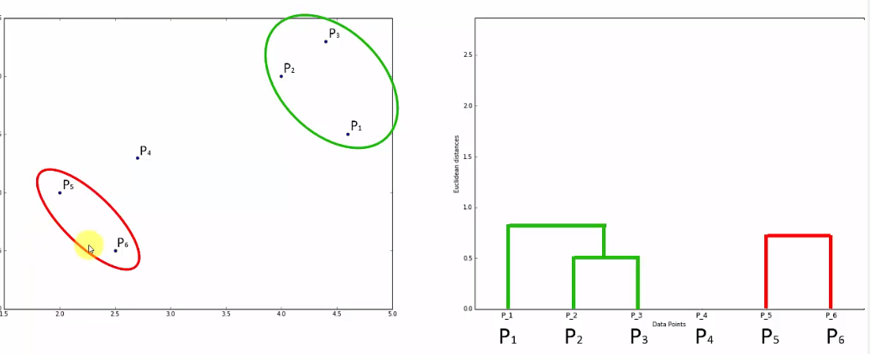

Since p4 is close to p5 and p6

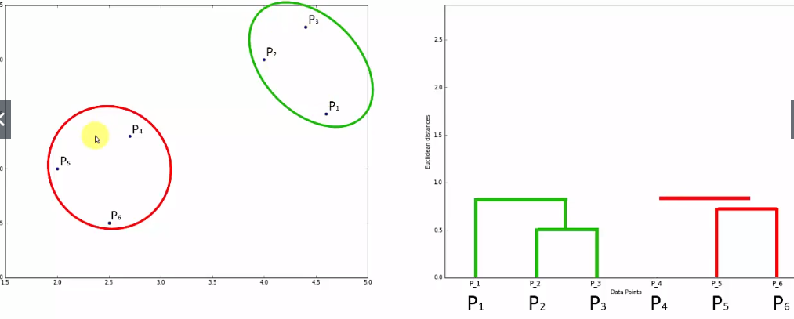

Final result on how computer construct the clustering grouping :

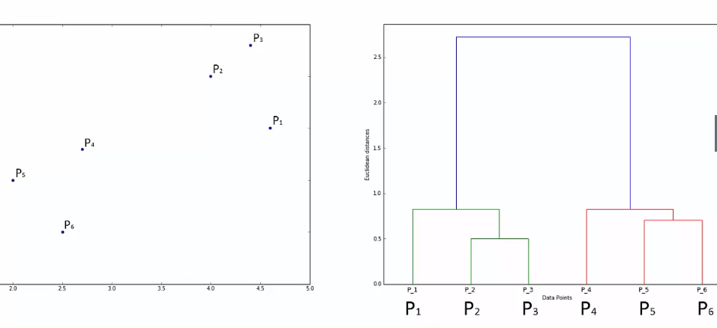

HC and dendrograms together:

Setting the thushhold on this level gives us 4 clusters because it cross 4 virtual lines

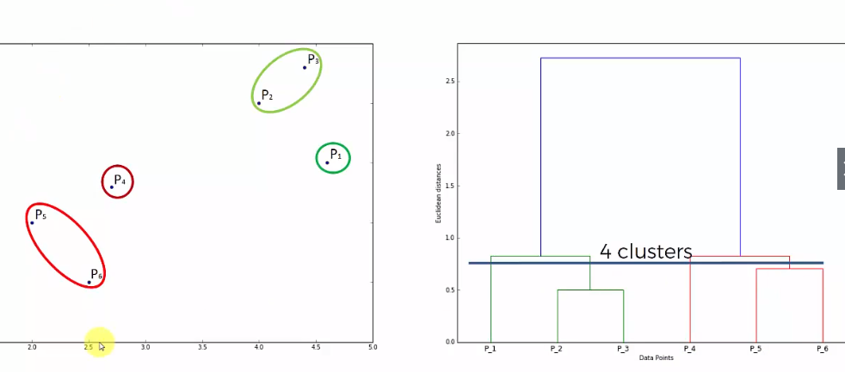

Setting a very low thrushold:

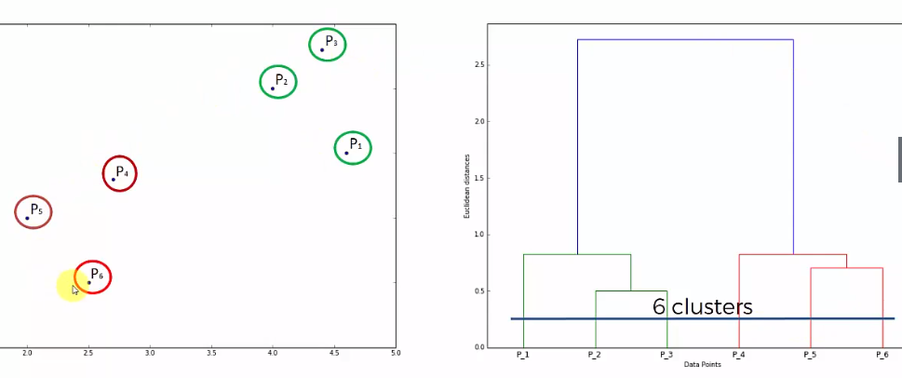

Draw vertical line for the longest line and then horizontal line in the middle of it. That is your first two clusters

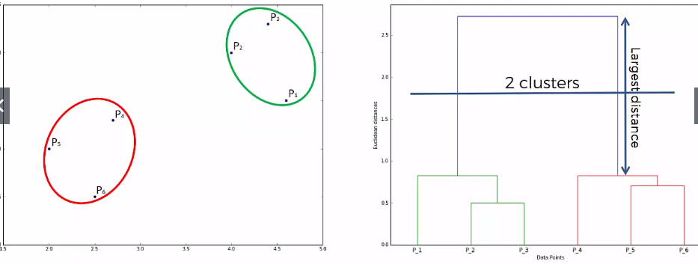

Example:

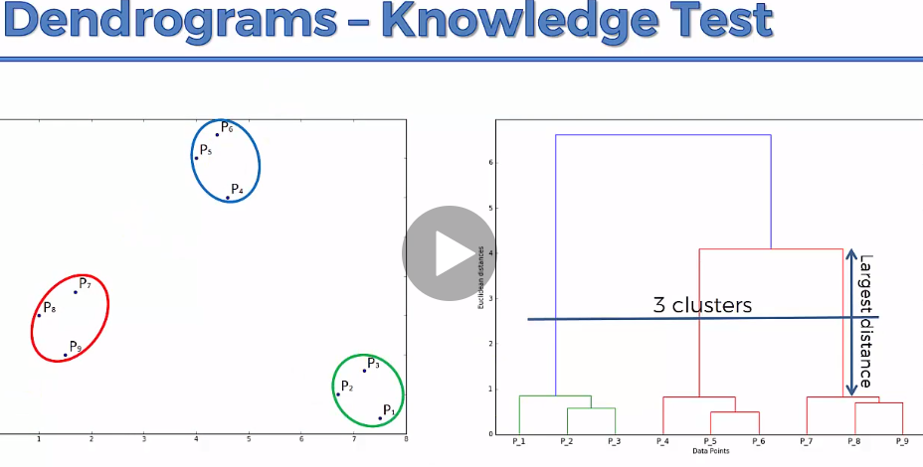

Business problem:

Based on several catiria the mall gave customers spending score from 0 to 100 because the mall wants to separate the customers into groups. That’s what make this problem a clustering problem.